Collins-Riverside Intermediate School
School Counseling Office
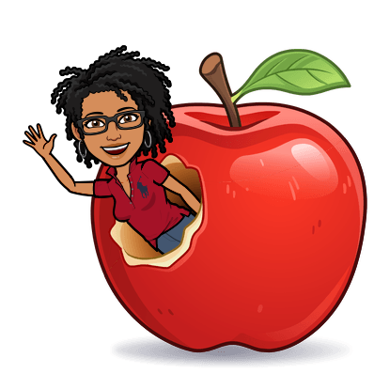First 9 Weeks Newsletter
About My School Counselor…
Marlana L. Mason
Masters of School Counseling, UWA
Bachelors of Secondary Education (Mathematics), UA
E-mail: mlmason@tcss.net
Phone: 205.342.2680 Fax: 205.247.4164

Some of the services provided by the school counseling office
include classroom lessons, small group lessons with parent permission, individual guidance, referrals to community resources, career exploration, and parent conference support.
I also serve as PowerSchool support, 504 Chair, Building Test Coordinator, and Adopt-A-School Coordinator.
The school counseling program helps every student become academically prepared and demonstrate respect, responsibility, and resilience by delivering activities that promote positive academic, career, and social/emotional development. Growing Together…Riverside Way, All Day!

How Students See the Counselor…
- Self-referral via Schoology, e-mail, or in-person with teacher permission
- Parent/Guardian request
- Faculty/Staff referral

Parents, please feel free to contact me by e-mail, phone, or appointment. I am here to work with the students, parents, and faculty/staff of Collins-Riverside Intermediate School.
Parent Resource: Alabama’s Parenting Assistance Line (PAL) is offering free parenting tips and information about local events and resources. Just text PAL to 274448 to sign up!

Upcoming Counseling Events…
- August: Welcome Back!! Focus: 3Rs and Reporting Bullying/Harassment
  - Core Essential Value is Creativity
- September: Healthy Relationships Focus: Healthy Relationships and Conflict Resolution
  - Core Essential Value is Friendship
- October: Health & Safety Focus: Healthy Choices and Self-Care
  - Core Essential Value is Integrity

Please Turn Over…


Important Information

- Open House – August 31
- Progress Reports – September 8
- Report Cards – October 13
- Parent Access codes for PowerSchool will go home August 21.
  - E-mail Mrs. Mason at mlmason@tcss.net if you need assistance

- Students will be asked to complete a Student Needs Assessment during school. Information gathered will be used to determine small groups offerings.
- School counseling information is made available through Schoology.
- A Parent Survey will also be available from August 21 through September 15.
  - A link will be pushed out through our school’s Facebook page.
  - The survey will be available on the school’s website under Our School – Counselor.
  - A QR code will be available at Open House.



